**A**

**PROJECT REPORT ON**

**GCOEY COLLEGE WEBSITE**

Submitted in partial fulfilment of requirements for the award of degree of

**BACHELOR OF TECHNOLOGY**

in

**Computer Engineering**

By

|  |  |
| --- | --- |
| **ATAL A. DUBEY** | **T2010121245007** |
| **KHUSHI V. CHATURKAR** | **T2010121245014** |
| **RAJAT S. PAWAR** | **T2010121245028** |

Under the Guidance of

**Prof. Dhiraj D. Shirbhate**

Department of Computer Engineering

Government College of Engineering, Yavatmal

2023-2024

Department of Computer Engineering

Government College of Engineering, Yavatmal

(An Institute of Government of Maharashtra)

***CERTIFICATE***

This is to certify that the Project report entitled

“**GCOEY COLLEGE WEBSITE”**

is a bonafide project work and has been carried out by team:

|  |  |
| --- | --- |
| Atal A. Dubey | (T2010121245007) |
| Khushi V. Chaturkar | (T2010121245014) |
| Rajat S. Pawar | (T2010121245029) |
|  |  |

of Final Year B-Tech class under the guidance of Prof. D. D. Shirbhate during the academic year 2023 -2024 (Sem-VIII).

|  |  |  |  |
| --- | --- | --- | --- |
| Prof. D. D. Shirbhate  **Project Guide** | |  | Prof. C. V. Andhare  **Head, Computer Department** |
|  |  | |  |
| Dr. V. B. Waghmare  **Principal** | | | |

Department of Computer Engineering

Government College of Engineering, Yavatmal

****(An Institute of Government of Maharashtra)

This is to certify that the Project report entitled

“**GCOEY COLLEGE WEBSITE**”

is a bonafide project work submitted by:

|  |  |
| --- | --- |
| Atal A. Dubey | (T2010121245007) |
| Khushi V. Chaturkar | (T2010121245014) |
| Rajat S. Pawar | (T2010121245028) |

in partial fulfilment for the award of degree of bachelor of technology In Computer Engineering.

|  |  |  |
| --- | --- | --- |
| Prof D. D. Shirbhate  **Project Guide** |  | Prof. C. V. Andhare  **Head, Computer Department** |

**Internal Examiner External Examiner**

# 

# **Abstract**

In the digital age, where technology serves as a cornerstone of modern education, the role of a college website transcends mere information dissemination. Our college website stands as a dynamic virtual portal, meticulously designed to enhance the student experience and foster academic excellence. Navigating through our website, students embark on a journey brimming with opportunities for growth, collaboration, and discovery. From comprehensive course catalogues to interactive academic calendars, every aspect is meticulously crafted to empower students in their educational pursuits. One of the pivotal features of our website is its seamless integration of resources. Students can access a plethora of online libraries, research databases, and academic journals, enriching their learning experience beyond the confines of traditional classrooms. Moreover, virtual learning platforms facilitate engaging discussions, collaborative projects, and interactive learning modules, transcending geographical boundaries and fostering a global community of learners. Beyond academics, our website serves as a hub for holistic development. From career guidance resources to extracurricular activity listings, students are empowered to explore their passions and cultivate a well-rounded skill set. Additionally, dedicated sections for student services provide comprehensive support, ensuring that every student receives the assistance they need to thrive both academically and personally.

**Keyword: *Student experience, Academic experience, Digital age, Technology in education, Virtual portal, Online resources, Student Convenience, Student service, etc.***

i

# **Acknowledgment**

We would like to express our deepest appreciation to all those who provided the possibility to complete this project report. A special gratitude we give to our fourth-year project mentor, **Prof. Dhiraj D. Shirbhate,** whose contribution in stimulating suggestions and encouragement helped us to coordinate our project. He gave us support from the start to the end of this project and kept us on the correct path.

It is our privilege to express our gratitude towards our project in-charge, **Prof. Dhiraj D. Shirbhate** for their valuable guidance, encouragement, inspiration and whole-hearted cooperation throughout the project work. We thank him for being a motivation through all our highs and importantly, our lows.

We deeply express our sincere thanks to our Head of Department **Prof. C. V. Andhare** for encouraging and allowing us to present the project on the topic “GCOEY COLLEGE WEBSITE” and providing us with the necessary facilities to enable us to fulfill our project requirements as best as possible. We take this opportunity to thank all faculty members and staff of Department of Computer Engineering, who have directly or indirectly helped our project.

We pay our respects to honourable Principal **Dr. V. B. Waghmare** for their encouragement. Our thanks and appreciations also go to our family and friends, who have been a source of encouragement and inspiration throughout the duration of the project.

ii

# **Table of Contents**

**Abstract** i

**Acknowledgment** ii

**Table of Contents** iii

**List of Figures** v

**List of Tables** vi

**Chapter 1: Introduction** 1

1.1 Introduction 1

1.1.1 Concept Of Guidance 1

1.1.2 Characteristics of Career Guidance 2

1.2 Motivation 2

1.3 Scope 2

1.4 Basic Concept 5

1.5 Objective 5

1.6 Software/ Hardware Requirement 6

1.6.1 System Analysis 6

1.6.2 Hardware Requirements 6

1.6.3 Software Requirements 7

**Chapter 2: Literature Review** 8

2.1 Overview 8

2.2 Literature Survey 9

2.2.1 Summary of Literature Review 12

**Chapter 3:** **Problem Definition and Methodology** 13

3.1 Problem Definition 13

3.2 Proposed Methodology 13

3.3 System Design 15

iii

3.3.1 System Model 15

3.3.2 ER Diagram 15

3.3.3 DFD 16

3.3.4 Data Dictionary 16

3.3.5 Flow Charts 16

**Chapter 4:** **Implementation** 19

4.1 Backend 19

4.2 Database 25

4.3 User Interfaces 27

**Chapter 5: Result and Discussion** 34

5.1 Result 34

5.1.1 Project Output 34

5.2 Discussion 36

**Chapter 6:** **Conclusion and Future Scope** 38

6.1 Conclusion 38

6.2 Future Scope 38

**References** 39

Journal References 39

Internet References 39

**Published Papers** 40

1. MongoDB: A Comprehensive Review........................................................40

2.A Comprehensive Review of JavaScript Framework......................................

iv

# **List of Figures**

Figure 1‑1: Types of Security 1

Figure 3‑1: Proposed Architecture 18

Figure 3‑2: System Model 19

Figure 3‑3: ER Diagram for website administrator 19

Figure 3‑4: DFD for Data Leakage detection System 20

Figure 3‑5: Flowchart for Login Page 24

Figure 3‑6:Flowchart for Registration Page 25

Figure 3‑7: Flowchart for File Sharing 26

Figure 3‑8: Flow Chart for Key Request 27

Figure 3‑9: Flowchart for File Downloading 28

Figure 3‑10: Flowchart for Leaker Detection 29

Figure 4‑1: MySQL Database 37

Figure.4‑2: Home Page 38

Figure 4‑3: Login Page 39

Figure 4‑4: Registration Page 39

Figure 4‑5: User Dashboard 40

Figure 4‑6: Profile Page 40

Figure 4‑7: Send Files Page 41

Figure 4‑8: Key Requests Page 41

Figure 4‑9: Shared by Me Page 42

Figure 4‑10: Shared With Me Page 42

Figure 4‑11: Admin Dashboard 43

Figure 4‑12: Leakers Page 43

Figure 4‑13: Contact Messages Data 44

Figure 5‑1: Watermark Output 45

Figure 5‑2: Leaker User List 46

Figure 5‑3: List of Leaked Messages 47

v

# **List of Tables**

Table 1‑1: Comparison Data Privacy And Data Security 4

Table 2‑1: Summary of Literature Review 15

Table 3‑1: Download Attempts Table 20

Table 3‑2: Users Table 21

Table 3‑3: Data Files Table 21

Table 3‑4: Key Requests Table 22

Table 3‑5: Notifications Table 22

Table 3‑6: Leaked Messages Table 23

Table 3‑7: Leakers Table 23

Table 3‑8: Contact Messages Table 23

vi

# **Introduction**

## 1.1 Introduction

Welcome to our college's digital gateway, where innovation meets education, and possibilities abound. In today's interconnected world, where technology reshapes every facet of our lives, our college website stands as a beacon of academic excellence and student empowerment. As you step into this virtual realm, you enter a realm where the traditional boundaries of learning dissolve, and a world of endless opportunities unfolds. Our website is not merely a collection of web pages but a dynamic platform meticulously designed to enhance every aspect of your educational journey.

* + 1. **Concept Of College Website:**
* A well-designed college website serves as a comprehensive digital portal that addresses the needs of various stakeholders, including prospective and current students, faculty, staff, alumni, and visitors. The homepage typically features a welcoming message, news and announcements, and quick links to popular sections like admissions, academic programs, and campus news. Essential sections such as "About Us," "Admissions," "Academics," and "Student Life" provide detailed information about the college's history, mission, academic offerings, and student services, ensuring visitors can easily access relevant information.
* Additionally, a robust "Research" section showcases the college's research centers, ongoing projects, and student research opportunities. The "Alumni" section keeps former students connected through alumni associations, event information, and giving opportunities. Ensuring a seamless user experience, the website incorporates responsive design for accessibility on various devices, adheres to accessibility standards for users with disabilities, and features a powerful search function for easy navigation. Finally, security and privacy measures are implemented to protect user data and maintain trust.

**1.1.2** **Characteristics of Career Guidance:**

* **User-Centric Design**: Easy-to-navigate menus and clear site structure to help users find information quickly.
* **Accessibility**: Compliance with accessibility standards (like WCAG) to support users with disabilities, including screen reader compatibility and text alternatives for non-text content.
* **Responsive Design**: Optimization for various devices, including desktops, tablets, and smartphones, ensuring a seamless user experience across platforms.
* **Comprehensive Content**: Detailed and up-to-date information about academic programs, admissions processes, campus facilities, student life, and research opportunities.
* **Engaging Media**: Use of images, videos, and virtual tours to provide a dynamic and engaging experience, helping to visually represent the college environment and culture.
* **Clear Calls to Action**: Prominent buttons and links that guide users to take desired actions, such as applying, scheduling a visit, or contacting the college.
* **Search Functionality**: A robust search engine that allows users to find specific information quickly and easily.
* **Interactive Features**: Online forms for applications, inquiries, and feedback, as well as portals for current students, faculty, and staff to access personalized information and services.
* **Security and Privacy**: Secure handling of personal information, including encrypted connections (HTTPS) and compliance with data protection regulations (like GDPR or FERPA).
* **Community Engagement**: Features like social media integration, alumni networks, and feedback mechanisms to foster community engagement and keep users connected and informed.

## 1.2 Motivation:

## Motivation for a college website could revolve around inspiring and engaging various stakeholders such as prospective students, current students, faculty, staff, alumni, and parents. Here are some motivational themes tailored to different audiences:

## Prospective Students:

## Showcase Success Stories: Highlight success stories of alumni who have achieved great things after graduating from the college.

## Virtual Campus Tours: Offer virtual tours of the campus, showcasing its facilities, vibrant student life, and academic resources.

## Testimonials and Reviews: Share testimonials and reviews from current students, faculty, and alumni about their positive experiences at the college.

## Current Students:

## Academic Achievements: Celebrate academic achievements, such as Dean's List honours, research awards, and academic scholarships, to motivate current students to strive for excellence in their studies.

## Student Success Stories: Feature stories of current students overcoming challenges, pursuing their passions, and making a difference in their communities.

## Leadership and Engagement Opportunities: Highlight leadership and engagement opportunities, such as student organizations, internships, and volunteer programs, to motivate students to get involved and make a positive impact on campus and beyond.

## Faculty and Staff:

## Recognition and Appreciation: Recognize and appreciate the contributions of faculty and staff members through features, testimonials, and awards. Feeling valued and appreciated can motivate faculty and staff to continue delivering high-quality education and support services.

## Collaboration and Innovation: Emphasize the college's commitment to collaboration and innovation, showcasing initiatives that promote interdisciplinary research, teaching excellence, and creative problem-solving.

## Alumni:

## Impact of Giving: Highlight the impact of alumni donations and philanthropic support on the college community, such as scholarships, research grants, and campus improvements. This can motivate alumni and donors to continue giving back and making a difference.

## 1.3 Scope

The scope of a college website is vast and multifaceted, encompassing a wide range of functionalities, features, and content to serve the needs of various stakeholders within the college community. Here are some key aspects that fall within the scope of a college website:

* **Informational Content**: The website serves as a primary source of information about the college, its history, mission, vision, values, and accreditation.
* **Student Resources:** The website offers a variety of resources and services to support students throughout their academic journey.
* **Faculty and Staff Resources:** The website provides resources and support for faculty and staff members, including access to administrative forms, human resources information, professional development opportunities, teaching resources, and faculty/staff directories.
* **Campus Life:** The website showcases the vibrant campus life and extracurricular activities available to students, including clubs, organizations, sports teams, cultural events, performing arts, and student publications..
* **Academic Support**: The website offers academic support services to help students succeed in their studies, such as tutoring programs, writing centers, academic advising, study skills workshops, and academic integrity resources.
* **Technology Services:** The website provides information about technology services and resources available to students, faculty, and staff, including access to campus Wi-Fi, computer labs, software downloads, online learning platforms (e.g., learning management systems), and IT support.
* **Alumni Engagement:** The website facilitates engagement with alumni by providing opportunities for networking, mentorship, and giving back to the college community
* **Accessibility and Compliance:** The website ensures accessibility and compliance with web accessibility standards (e.g., WCAG) to ensure that all users, including those with disabilities, can access and navigate the website effectively.

## 1.4 Basic Concept

The basic concept of a college website revolves around serving as a comprehensive online platform that caters to the diverse needs of the college community, including prospective students, current students, faculty, staff, alumni, and parents. Here are some fundamental elements of a college website:

* **Information Hub**: The website serves as a central repository of information about the college, its history, mission, vision, values, and academic programs. It provides details about admission requirements, application procedures, tuition fees, financial aid options, and campus facilities.
* **Academic Programs:** The website features detailed information about academic programs offered by the college, including undergraduate and graduate programs, majors, minors, concentrations, and certificate programs.

## 1.5 Objective

The objectives of a college website can vary depending on the institution's goals, target audience, and overall mission. However, some common objectives include:

* **Information Dissemination**: One of the primary objectives of a college website is to provide accurate and up-to-date information about the institution, its programs, admissions process, faculty, staff, facilities, and academic offerings. This helps prospective students, current students, parents, alumni, and other stakeholders make informed decisions about the college.
* **Recruitment and Enrollment**: A college website serves as a marketing tool to attract prospective students and encourage them to apply for admission. By showcasing the college's unique features, academic excellence, campus culture, and student life, the website aims to increase enrollment and attract qualified applicants.
* **Student Support Services**: The website provides resources and support services to help students succeed academically, personally, and professionally. This includes information about academic advising, counseling services, career development resources, tutoring programs, disability support services, and student organizations.
* **Alumni Engagement**: The website facilitates engagement with alumni by providing opportunities for networking, mentorship, and involvement in college activities. It helps alumni stay connected with their alma mater, share their success stories, and contribute to the college community through donations, volunteering, and participation in events.
* **Faculty and Staff Support**: The website offers resources and support for faculty and staff members, including access to administrative forms, human resources information, professional development opportunities, teaching resources, and faculty/staff directories.
* **Community Outreach**: The website serves as a platform for community outreach and engagement, sharing information about college events, public lectures, cultural activities, and partnerships with local organizations. It promotes collaboration and interaction between the college and the broader community.

## 1.6 Software/ Hardware Requirement

### ****System Analysis****

### System analysis is the process of gathering and interpreting facts, diagnosing problems and using the information to recommend improvements on the system. System analysis is a problem solving activity that requires intensive communication between the system users and system developers. System analysis or study is an important phase of any system development process. The system is studied to the minutest detail and analyzed. The system analyst plays the role of an interrogator and dwells deep into the working of the present system. The system is viewed as a whole and the inputs to the system are identified. The outputs from the organization are traced through the various processing that the inputs phase through in the organization. A detailed study of these processes must be made by various techniques like Interviews, Questionnaires etc. The data collected by these sources must be scrutinized to arrive to a conclusion. The conclusion is an understanding of how the system functions. This system is called the existing system. Now, the existing system is subjected to close study and the problem areas are identified. The designer now functions as a problem solver and tries to sort out the difficulties that the enterprise faces. The solutions are given as a proposal. The proposal is then weighed with the existing system analytically and the best one is selected. The proposal is presented to the user for an endorsement by the user. The proposal is reviewed on user request and suitable changes are made. This loop ends as soon as the user is satisfied with the proposal.

### EXISTING SYSTEM

### The existing college website is static which makes it less interactive. It doesn't have a database connectivity. Moreover students didn't have an access to the details of the college through the site, hence they were not updated about the latest events and placement drives.

### PROPOSED SYSTEM

### The proposed college website system will feature a dynamic admin panel designed to streamline content management and enhance user experience. This admin panel will allow authorized personnel to easily update website content, including academic program details, admission requirements, news updates, and event calendars. It will provide intuitive tools for uploading media, managing user accounts, and monitoring site analytics. The dynamic nature of the admin panel ensures that the website remains current and relevant, accommodating real-time changes and promoting efficient communication between the college and its stakeholders. Enhanced security measures will be integrated to safeguard sensitive data, ensuring compliance with privacy regulations and maintaining the integrity of the website. This robust system will support the college’s mission to provide accurate, timely information to prospective students, current students, faculty, staff, and alumni.

### 1.6.2 Hardware Requirements

**Disk:** Capacity >500MB for smooth performance

**RAM:** 2GB (minimum) and above.

**Processor:** Intel Core 2 Quad or Intel i3-5th Gen and above (recommended)

### 1.6.3 Software Requirements

**OS:** Windows 7 and above or linux

**Front End Technology:** HTML5 CSS3, JavaScript.

**Backend Technology:** PHP & MySql

**Code Editor:** Visual Studio Code, Notepad or Other Code Editor

**Web Browser:** Google Chrome, Mozilla Firefox, Opera or Other Web Browser.

# **Literature Review**

## 2.1 Overview

**What is it?**

College websites typically serve as comprehensive online platforms where prospective students, current students, faculty, staff, alumni, and the general public can access information about the institution.

**Who can benefit?**

* Prospective Students: College websites provide information about academic programs, admissions requirements, campus facilities, and student life, helping prospective students make informed decisions about which college to attend.
* Current Students: Current students can access resources such as course schedules, academic calendars, grades, campus news, and student services through the website. They can also stay updated on campus events and opportunities.
* Faculty and Staff: Faculty and staff can find information about academic policies, administrative procedures, professional development opportunities, campus events, and access internal resources and tools through the website**.**

**What does it involve?**

Creating and maintaining a college website involves various steps and tasks, including:

* **Planning and Strategy:** Determine the purpose and goals of the website, identify the target audience, and establish a content strategy. Consider factors such as branding, user experience, accessibility, and mobile responsiveness.
* **Content Creation:** Develop content for the website, including text, images, videos, and other multimedia elements. Content should be accurate, up-to-date, and aligned with the college's messaging and branding guidelines.
* **Design and Layout:** Design the layout and structure of the website, including navigation menus, page templates, and visual elements such as colors, fonts, and graphics. Ensure that the design is user-friendly, visually appealing, and consistent with the college's branding.
* **Development and Coding:** Build the website using web development technologies such as HTML, CSS, JavaScript, and content management systems (CMS) like WordPress or Drupal. Implement features such as forms, interactive elements, and database integration as needed.
* **Accessibility and Compliance:** Ensure that the website meets accessibility standards (e.g., WCAG guidelines) to accommodate users with disabilities. Comply with relevant regulations and policies, such as GDPR for data privacy and FERPA for student information protection.
* **Testing and Quality Assurance:** Test the website for functionality, compatibility, performance, and usability across different devices and browser.

## 2.2 Literature Survey

### [1] ****“Usability Evaluation of University Websites” by Al-Turki, et al. (2016)****

* **Summary**: This study evaluates the usability of university websites in Saudi Arabia. The researchers used a heuristic evaluation method to assess the websites' navigability, design, content quality, and accessibility. The study found that while many university websites provided comprehensive information, they often lacked user-friendly navigation and accessibility features, which are crucial for effective information dissemination and user engagement.
* **Key Findings**: Importance of user-centred design, need for better accessibility features, and the impact of usability on user satisfaction and engagement.

### [2] ****“Website Usability and Content Accessibility of the Top 10 US Universities” by Jeong and Stylianou (2018)****

* **Summary**: This paper examines the usability and content accessibility of the websites of the top 10 universities in the United States. The authors used automated tools and manual evaluation techniques to assess the compliance with Web Content Accessibility Guidelines (WCAG). The study highlighted significant variations in usability and accessibility standards across these websites.
* **Key Findings**: Discrepancies in adherence to accessibility guidelines, need for standardization, and the role of usability in enhancing user experience.

### [3] ****“Development and Evaluation of a Student-Centric University Portal” by Agrawal, et al. (2017)****

* **Summary**: This research focuses on the development of a student-centric university portal that integrates various services such as course registration, grades, library access, and event notifications. The portal was evaluated using surveys and usability testing with actual students. The findings emphasized the importance of integrating various services into a single platform to improve usability and student satisfaction.
* **Key Findings**: Benefits of integrated services, user feedback on portal functionality, and the need for continuous updates and improvements based on user input.

### [4] ****“Enhancing University Website Design to Better Meet User Needs” by Huang and Benyoucef (2013)****

* **Summary**: This paper explores how university websites can be designed to better meet the needs of diverse user groups, including prospective students, current students, faculty, and alumni. The authors conducted a series of user studies to identify key features and content that users find most valuable. They also provided design recommendations based on their findings.
* **Key Findings**: Importance of understanding user needs, prioritization of content and features, and recommendations for user-friendly design practices.

### [5] ****“Evaluating the Effectiveness of College Websites in Attracting Prospective Students” by McAllister and Lister (2015)****

* **Summary**: This study investigates the role of college websites in attracting prospective students. The authors used a combination of analytics, surveys, and eye-tracking studies to understand how prospective students interact with college websites and what information they seek. The results showed that clear navigation, detailed program information, and engaging media content were critical factors in attracting and retaining prospective students.
* **Key Findings**: Effective content strategies, the importance of visual appeal and multimedia, and the impact of website design on prospective students' decision-making processes.

**2.2.1 Summary of Literature Review**

Table 2‑1: Summary of Literature Review

# 

# **Definition and Methodology**

## 3.1 Problem Definition

The problem definition typically outlines the issue or challenge that needs to be addressed or solved. In the context of a college website, the problem definition could vary depending on the specific circumstances or goals of the institution. Here are some examples of problem definitions related to college websites:

1. **Low Website Traffic**: The college website is not receiving a sufficient number of visitors, resulting in low engagement and limited reach to prospective students, faculty, staff, alumni, and other stakeholders.
2. **Poor User Experience**: Users encounter difficulties navigating the website, finding information, or completing tasks, leading to frustration and dissatisfaction with the user experience.
3. **Outdated Content**: The website contains outdated or inaccurate information about academic programs, admissions requirements, campus facilities, or other relevant topics, causing confusion and misinformation among visitors.
4. **Accessibility Issues**: The website is not fully accessible to users with disabilities, in violation of accessibility standards and regulations, leading to exclusion and discrimination against individuals with disabilities.
5. **Security Vulnerabilities**: The website is vulnerable to security threats such as hacking, malware, data breaches, or phishing attacks, putting sensitive information at risk and damaging the reputation of the college

**Research Questions:**

* How does the design of the college website impact user experience for prospective students during the admissions process?
* What elements of the website design contribute to positive user engagement and satisfaction among current students and faculty?
* How can the website's navigation structure and layout be improved to enhance usability and accessibility for all users?

## 3.2 Proposed Methodology

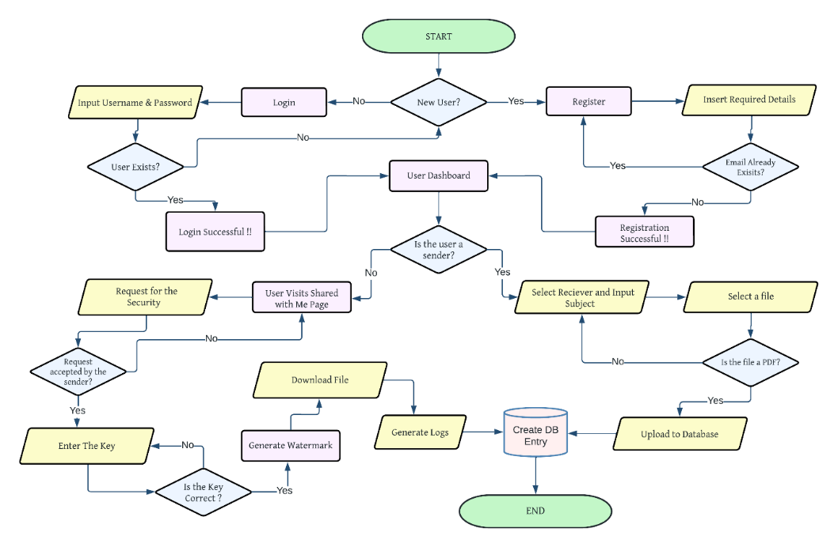

Figure 3‑1: Proposed Architecture

## Here's a proposed methodology that can be adapted based on the specific research objectives and resources available:

## Literature Review:

## Conduct a thorough review of existing literature, research studies, and best practices related to college website design, user experience, accessibility, and impact on recruitment and retention.

## Identify key concepts, theories, methodologies, and findings that can inform the research study.

## Quantitative Analysis:

## Collect quantitative data through surveys, website analytics, or quantitative content analysis to gather insights into user behaviour, preferences, and satisfaction levels.

## Develop and distribute surveys to targeted groups such as prospective students, current students, faculty, staff, and alumni to gather feedback on website usability, content relevance, and overall satisfaction.

## Qualitative Research:

## Conduct qualitative research methods such as interviews, focus groups, or usability testing to gain in-depth insights into user experiences, perceptions, and needs related to the college website.

## Schedule interviews or focus groups with representatives from different user groups (e.g., prospective students, current students, faculty, staff) to explore their experiences, challenges, and suggestions for website improvement.

## Accessibility Evaluation:

## Evaluate the accessibility of the college website using established guidelines and standards such as the Web Content Accessibility Guidelines (WCAG) 2.0 or 2.1.

## Conduct manual accessibility audits and automated accessibility testing using tools like WAVE, Axe, or Site improve to identify accessibility barriers and areas for improvement.

## Content Analysis:

## Analyse the content of the college website to assess its accuracy, relevance, and alignment with the institution's goals and values.

## Use qualitative content analysis techniques to examine the clarity, tone, and comprehensiveness of website content across different sections and pages.

## Technology Assessment:

## Assess the technological infrastructure supporting the college website, including web hosting, content management systems (CMS), and third-party integrations.

## Evaluate the scalability, security, and performance of the website's technical architecture to identify potential bottlenecks or vulnerabilities.

## 3.3 System Design

### 3.3.1 System Architecture

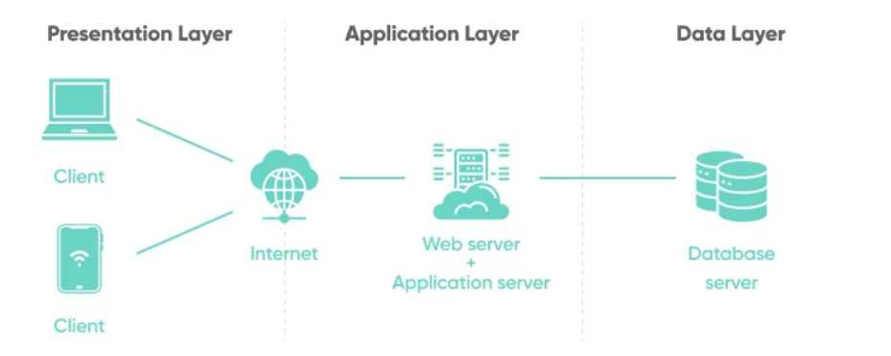

Figure 3‑2: System Architecture

### 3.3.2 ER Diagram

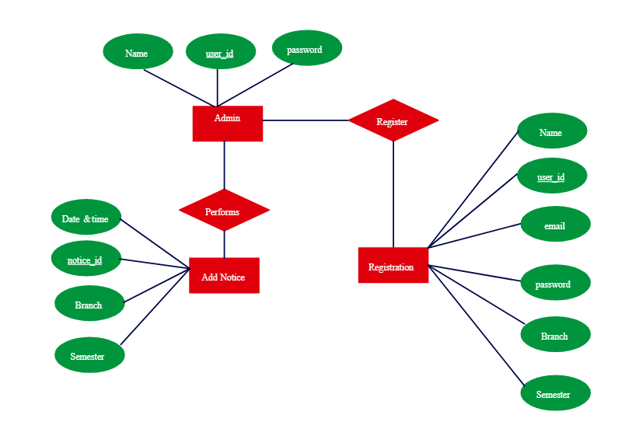

Figure 3‑3: ER Diagram for website administrator

In this ER Diagram, we have four main entities: “User”, ”File”, ”Leaker”, ”Request”.

1. The “User” entity represent the users of the system. It has attributes such as Fname, Lname, Date Time, UID, Email, Psword, UserType.
2. The File entity represents the data file of user. It has attributes such as Title, Id, User_Id, Date Time, Scret_key, About, Name.

### 3.3.4 Flow Charts

#### Admin Login Page

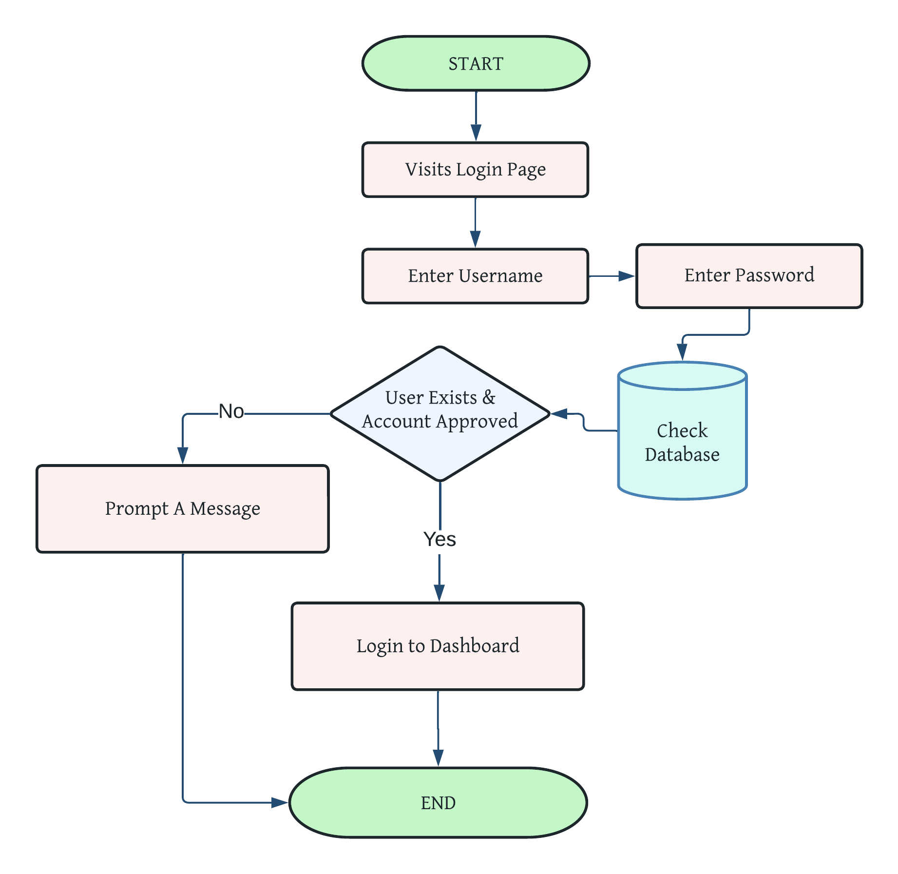

Figure 3‑5: Flowchart for Login Page

The admin begins by accessing the login page and providing their mail and password. Firebase then verifies this information against the database and allows the admin to proceed if the account exists and is approved. If the account is not approved, a prompt message is displayed. Once approved, the admin is directed to the dashboard and the process is terminated.



# **Implementation**

### 4.1Backend: Implementing the backend for a college website using Firebase involves several steps to set up authentication, database, storage, and functions. Here's an overview of the implementation process:

### 1. Authentication Setup

* **Create Firebase Project**: Begin by creating a new project in the Firebase console.
* **Enable Authentication**: Navigate to the Authentication section in the console and enable the authentication methods you want to use, such as email/password, Google sign-in, or others.
* **Integrate Authentication in Website**: Implement authentication functionality in your website using Firebase Authentication SDK. This includes sign-up, login, logout, and password reset features.

### 2. Realtime Database or Firestore Setup

* **Choose Database**: Decide whether to use Firebase Realtime Database or Cloud Firestore based on your data structure and requirements.
* **Initialize Database**: Initialize your chosen database in the Firebase console and configure security rules to control access.
* **Connect Database to Website**: Use Firebase SDKs to connect your website to the database and perform CRUD operations (Create, Read, Update, Delete) on data. This includes fetching and displaying information such as course details, event schedules, and user profiles.

### 3. Storage Setup

* **Enable Storage**: Enable Firebase Storage in the console to store and serve user-generated content such as images, videos, and documents.
* **Set Up Security Rules**: Configure security rules to control access to stored files based on user authentication and authorization.
* **Integrate Storage in Website**: Use Firebase Storage SDK to upload and retrieve files from storage. For example, allow users to upload profile pictures or submit assignments.

### 4. Cloud Functions (Optional)

* **Create Functions**: Write server-side logic using Firebase Cloud Functions to handle background tasks, such as sending notification emails, processing payments, or executing complex operations.
* **Deploy Functions**: Deploy functions to Firebase Cloud Functions and configure triggers to execute them in response to specific events, such as database changes or HTTP requests.
* **Integrate Functions in Website**: Invoke cloud functions from the website frontend to perform tasks that require server-side processing.

### 5. Error Handling and Logging

* **Handle Errors**: Implement error handling mechanisms in your website to gracefully handle authentication errors, database read/write failures, and other potential issues.
* **Monitor Logs**: Monitor logs and analytics in the Firebase console to track errors, user activity, and performance metrics. Use Firebase Analytics to gain insights into user behaviour and optimize website functionality accordingly.

### 6. Testing and Deployment

* **Test Locally**: Test backend functionality locally to ensure everything works as expected before deploying to production.
* **Deploy to Firebase Hosting**: Deploy your website frontend and backend to Firebase Hosting using Firebase CLI or integration with your preferred CI/CD pipeline.
* **Monitor Performance**: Monitor website performance, scalability, and security after deployment. Use Firebase tools and services to identify and address any issues that arise.

### 4.2 Database

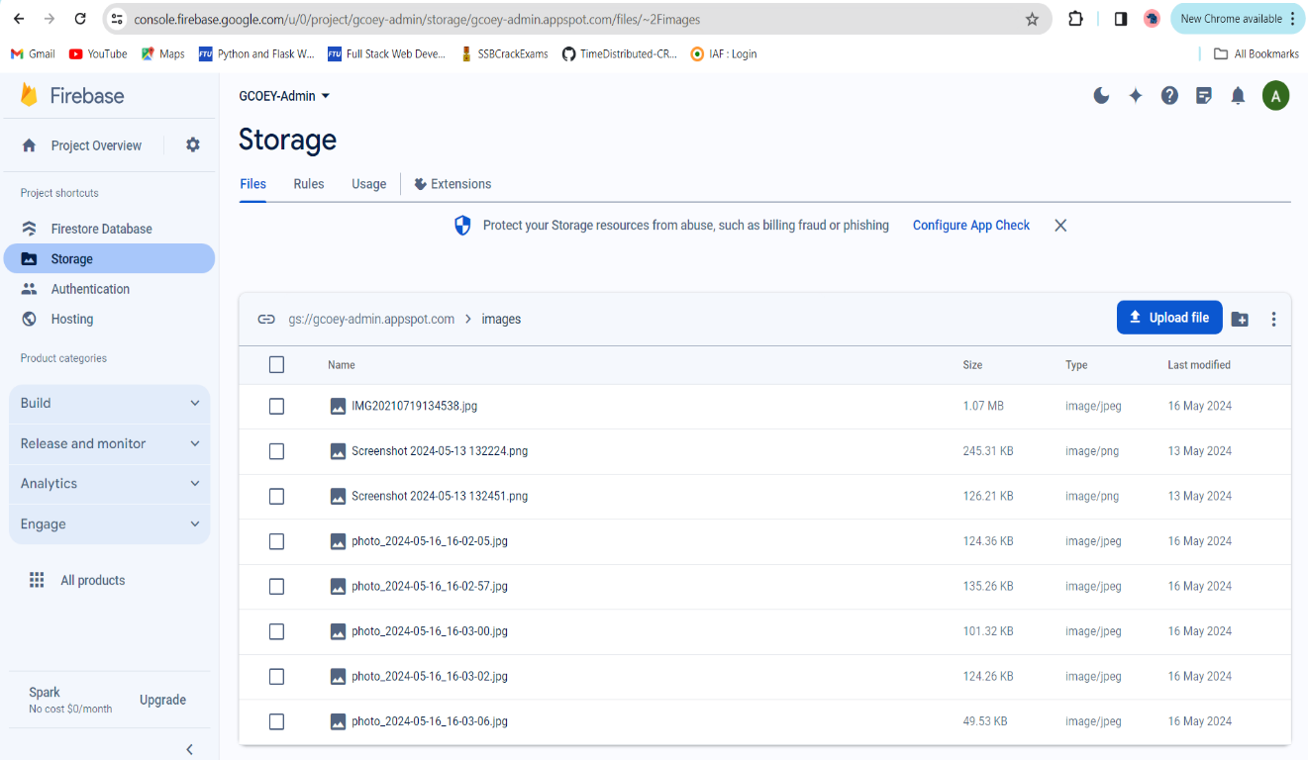

Figure 4‑1: Firebase Storage

Firebase Storage offers a streamlined solution for storing and serving images in your college website. It provides a secure and reliable platform to upload and manage images, ensuring efficient delivery to users. Integrated seamlessly with Firebase services, Firebase Storage simplifies backend infrastructure setup. With features like access control rules and automatic scaling, it guarantees secure storage and swift image retrieval, optimizing user experience. Whether managing user profile pictures, event photos, or campus snapshots, Firebase Storage offers a flexible and scalable solution for image storage needs, making it an ideal choice for building dynamic and engaging college websites.

Additionally, Firebase Storage's integration with Firebase Authentication ensures secure access control, allowing only authorized users to upload or access images. With its seamless scalability, Firebase Storage adapts to your website's growing image storage demands, making it an indispensable tool for creating visually appealing and dynamic college websites.

### 4.3 User Interfaces

#### Home Page

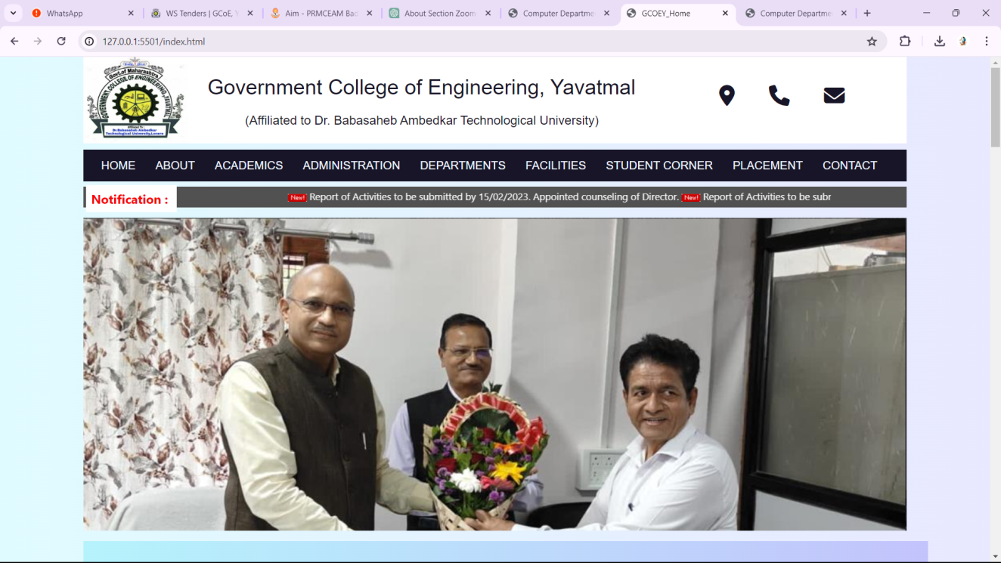

Figure.4‑2: Home Page

In our Project, this the home page of our College website. In the home page we have added the events and achievements which had held in our college.

#### Admin Page

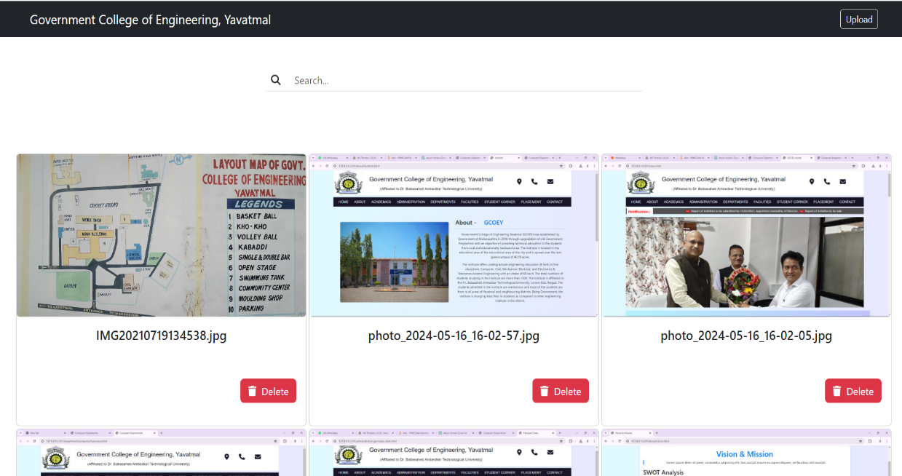

Figure 4‑4: Admin Page

Admin page is there to upload image for the website and it has many more functionality for the same.

#### User Section

##### About Page

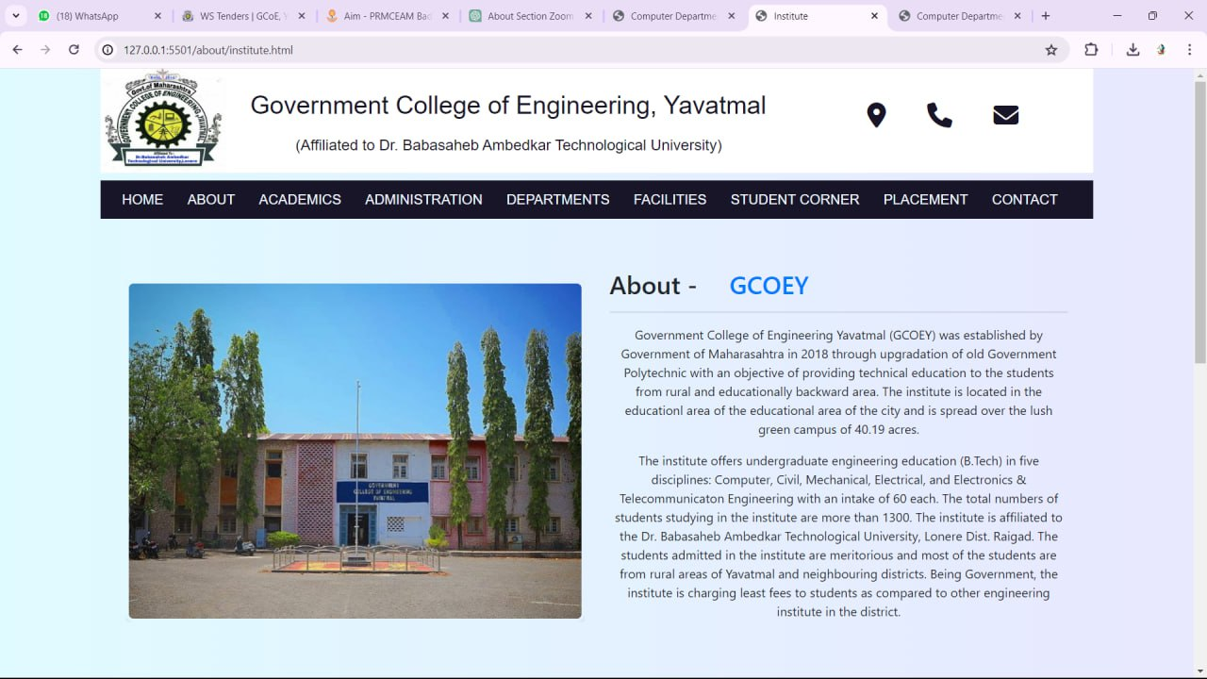

Figure 4‑5: About Page

Here we can get the information about the college and various aspect of it.

##### Vision and Mission Page

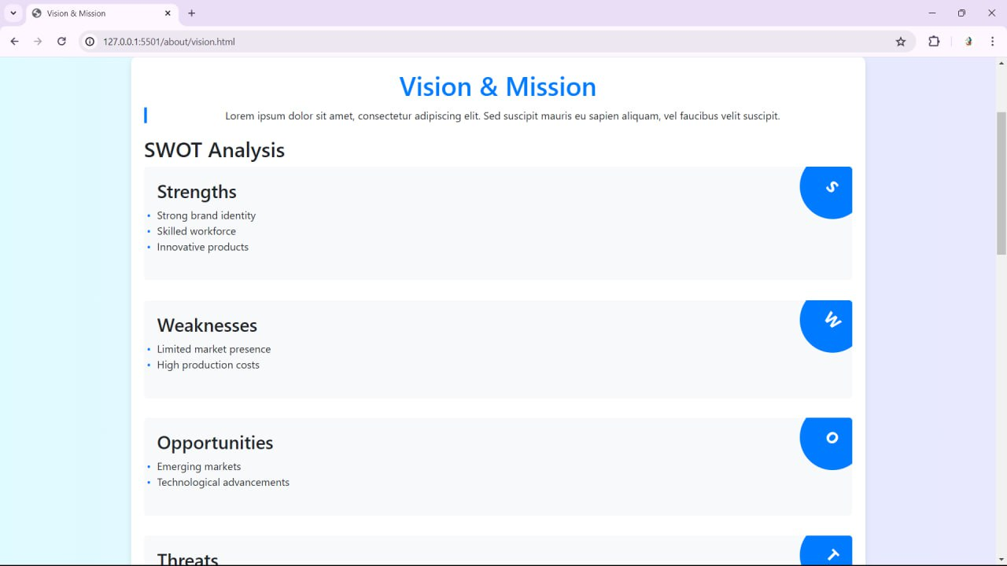

Figure 4‑6: Vision and Mission Page

If we want to know about the vision and mission of the college then we can visit here to get the full account of the college SWOT analysis.

##### Contact Page

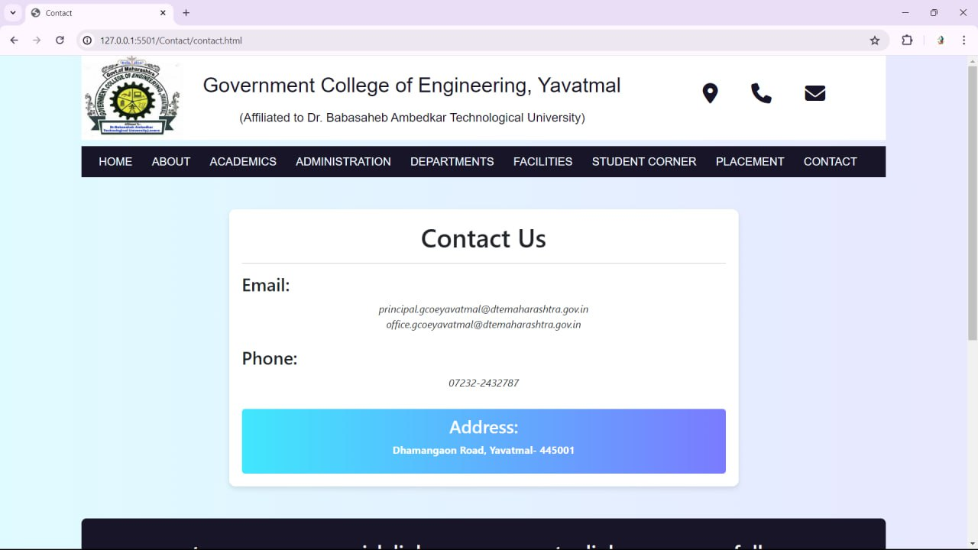

Figure 4‑7: Contact Page

If we want to find any contact detail then we can easily search this page.

##### Notification Pane

Figure 4‑8: Notification panel

Here we get to know about various ongoing event in the college.

# **Result and Discussion**

## 5.1 Result

The results of a college website can be profound, significantly impacting both the institution and its stakeholders. Firstly, from a student-centric perspective, the website acts as a gateway to vital information such as admissions processes, academic programs, and campus events. The website's effectiveness in delivering clear and concise information can streamline the application process, empower prospective students to make informed decisions, and foster a sense of community by showcasing campus life through engaging multimedia content. Furthermore, features like virtual tours and interactive maps enhance the overall user experience, offering a glimpse into campus facilities and amenities.

Secondly, for faculty, staff, and administration, the college website serves as a centralized platform for communication, collaboration, and resource management. It provides access to administrative tools, academic resources, and institutional policies, streamlining workflows and promoting efficiency. Additionally, internal portals and document repositories facilitate information sharing and support collaboration among faculty and staff members. By improving communication channels and providing easy access to essential resources, the website contributes to a more cohesive and productive campus environment. Overall, the results of a well-designed college website manifest in increased accessibility, engagement, and efficiency, ultimately enhancing the educational experience for all stakeholders involved.

## 5.2 Discussion

College websites represent the digital frontiers of academic institutions, embodying their ethos, mission, and offerings in the online sphere. These platforms serve as comprehensive repositories of information, catering to a wide array of stakeholders including prospective and current students, faculty, staff, alumni, and the broader community. Through meticulously curated content, college websites provide vital resources such as academic program details, admissions guidelines, campus news, event calendars, and student support services. They serve as dynamic portals facilitating seamless access to essential information and services, thereby enhancing the overall user experience and engagement within the collegiate community.

Beyond serving as repositories of information, college websites play a pivotal role in shaping the perception and identity of academic institutions. Through strategic design elements, multimedia content, and interactive features, these platforms convey the culture, values, and achievements of the college to external audiences. Visually appealing layouts, vibrant imagery, and compelling narratives paint a vivid picture of campus life, academic excellence, and extracurricular opportunities, enticing prospective students and fostering a sense of belonging among current members of the college community. By leveraging digital storytelling techniques and user-centric design principles, college websites contribute to enhancing the institution's brand visibility, reputation, and recruitment efforts in the competitive landscape of higher education.

Furthermore, college websites serve as dynamic communication channels, facilitating dialogue and collaboration among various stakeholders. Through news feeds, blogs, social media integrations, and discussion forums, these platforms foster a sense of community, engagement, and participation within the college ecosystem. Whether sharing campus updates, celebrating student achievements, or soliciting feedback from the community, college websites serve as conduits for meaningful interactions and connections that transcend geographical boundaries. By embracing digital innovations and leveraging emerging technologies, college websites remain at the forefront of facilitating collaboration, innovation, and knowledge dissemination within the academic community, thereby enriching the overall educational experience and advancing the mission of the institution in the digital age.

# **Conclusion and Future Scope**

## 6.1 Conclusion

The college website project aims to address key challenges and opportunities related to the design, functionality, and impact of the college website. Through a comprehensive methodology encompassing literature review, quantitative and qualitative research methods, accessibility evaluations, content analysis, and technology assessments, valuable insights have been generated to inform website optimization and strategic decision-making.

## 6.2 Future Scope

In the future, college websites will continue to play a crucial role in higher education by serving as dynamic digital platforms that facilitate communication, collaboration, and engagement among students, faculty, staff, alumni, and the broader community. Here are several ways in which college websites will be helpful in the future

1. **Enhanced Interactivity and Engagement**: College websites will evolve to offer highly interactive and engaging experiences, leveraging advanced technologies such as gamification, virtual reality (VR), and augmented reality (AR). These features will enable students to explore virtual campus tours, participate in immersive learning experiences, and collaborate with peers in virtual environments. Interactive elements like quizzes, forums, and real-time feedback mechanisms will foster active student engagement and facilitate deeper learning experiences.
2. **Integration of AI and Chatbots**: The integration of artificial intelligence (AI) and chatbots will revolutionize the user experience on college websites. AI-powered chatbots will provide personalized assistance to students, answering queries, offering academic guidance, and facilitating course selection. These intelligent systems will also automate administrative tasks, such as scheduling appointments, sending reminders, and providing instant support, thereby improving operational efficiency and enhancing user satisfaction.

# **References**

### Journal References

1. Kumar, P., & Chandel, S. (2014). "Evaluation of University Websites: A Comparative Study of Top World Universities" - International Journal of Computer Applications. DOI: 10.5120/17645-2538.
2. Huang, Y., & Benyoucef, M. (2013). "Enhancing University Website Design to Better Meet User Needs" - Journal of Educational Technology & Society. DOI: 10.1016/j.chb.2015.05.022.
3. Jeong, M., & Stylianou, A. (2018). "Website Usability and Content Accessibility of the Top 10 US Universities" - Journal of Information Technology Education: Research. DOI: 10.28945/4006.
4. McAllister, D., & Lister, M. (2015). "Evaluating the Effectiveness of College Websites in Attracting Prospective Students" - Journal of Marketing for Higher Education. DOI: 10.1080/08841241.2015.1061836.
5. Al-Turki, U., et al. (2016). "Enhancing the Usability of University Websites: A Usability Study of Saudi Arabian Universities" - International Journal of Advanced Computer Science and Applications. DOI: 10.14569/ijacsa.2016.070122.
6. Gholami, R., & Masrom, M. (2014). "User Perception of University Website Quality: An Empirical Examination in Iran" - Campus-Wide Information Systems. DOI: 10.1108/CWIS-06-2013-0037.
7. Bhat, S. A., & Paray, R. A. (2019). "Assessing the Usability of College Websites: A Case Study of Indian Universities" - International Journal of Engineering Research & Technology. DOI: 10.17577/IJERTV8IS030269.

### Internet References

1. OPEN AI. (n.d.). *CHATGPT*. CHATGPT-OPEN AI. <https://chat.openai.com/chat>
2. *Wikipedia*. (n.d.). <https://www.wikipedia.org/>

**Published Paper’s**

**MongoDB: A Comprehensive Review**

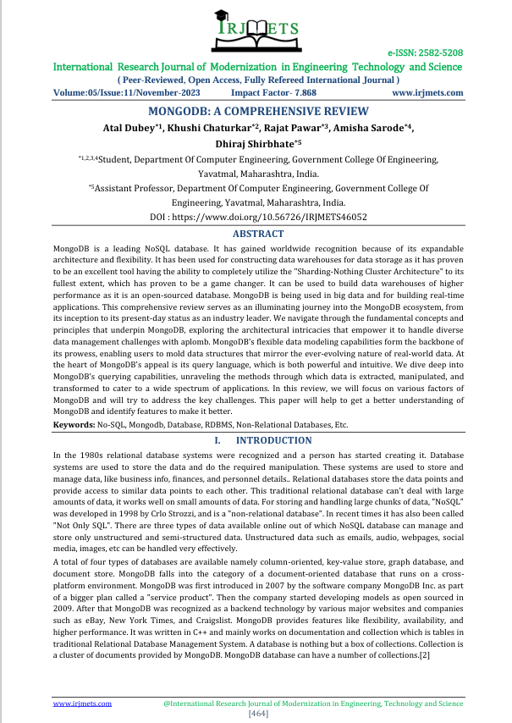

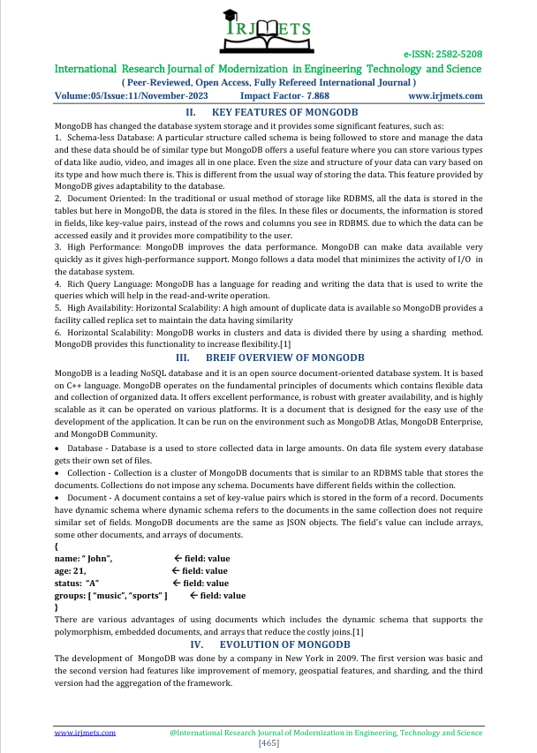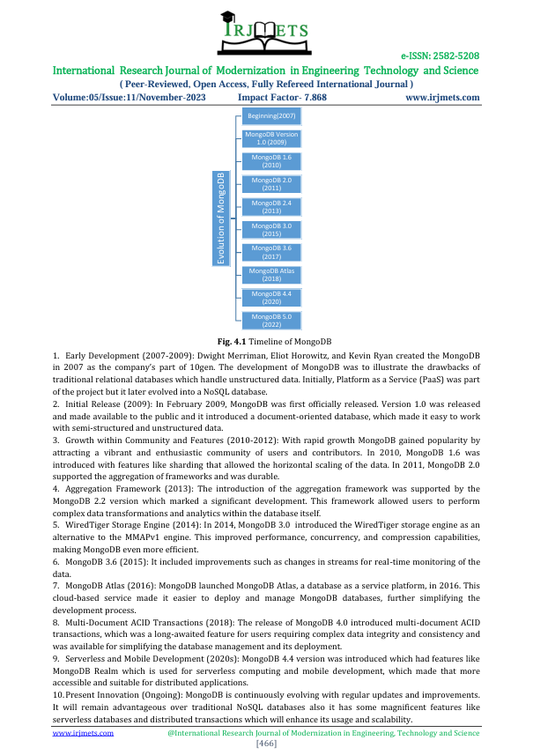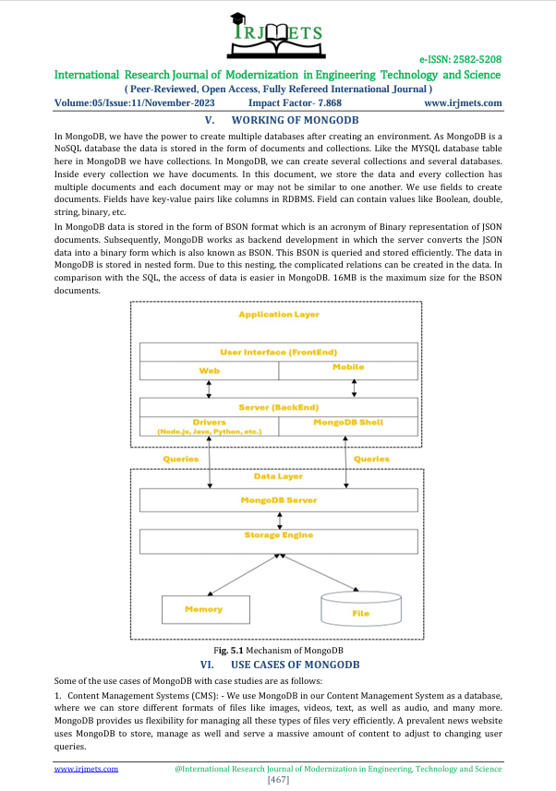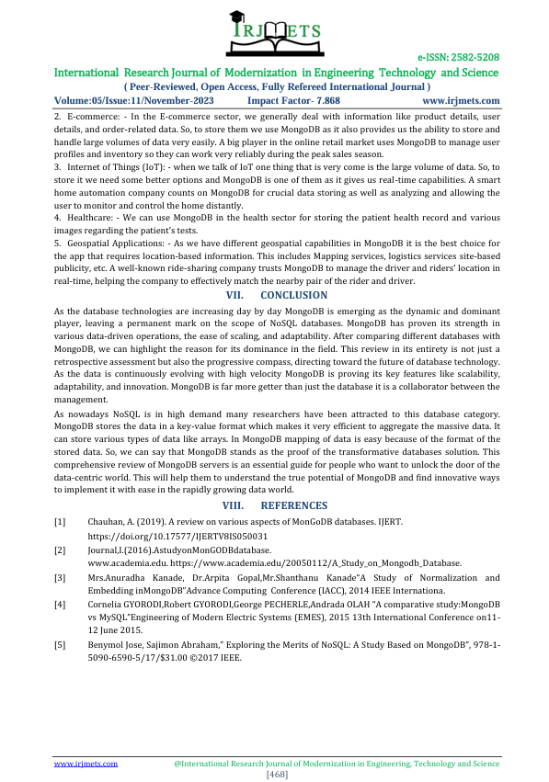

# **Certificates**

**A Comprehensive Review of JavaScript Frameworks**

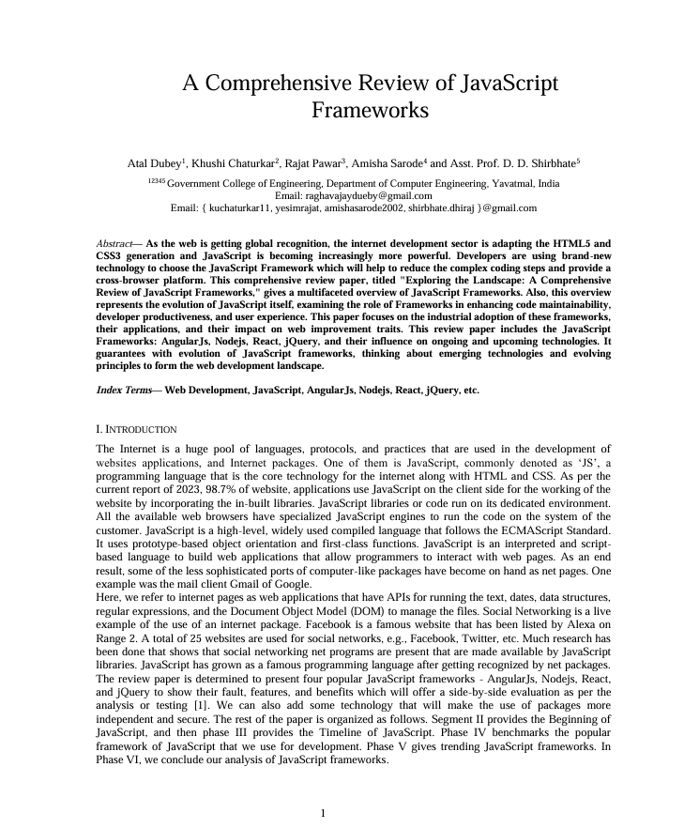

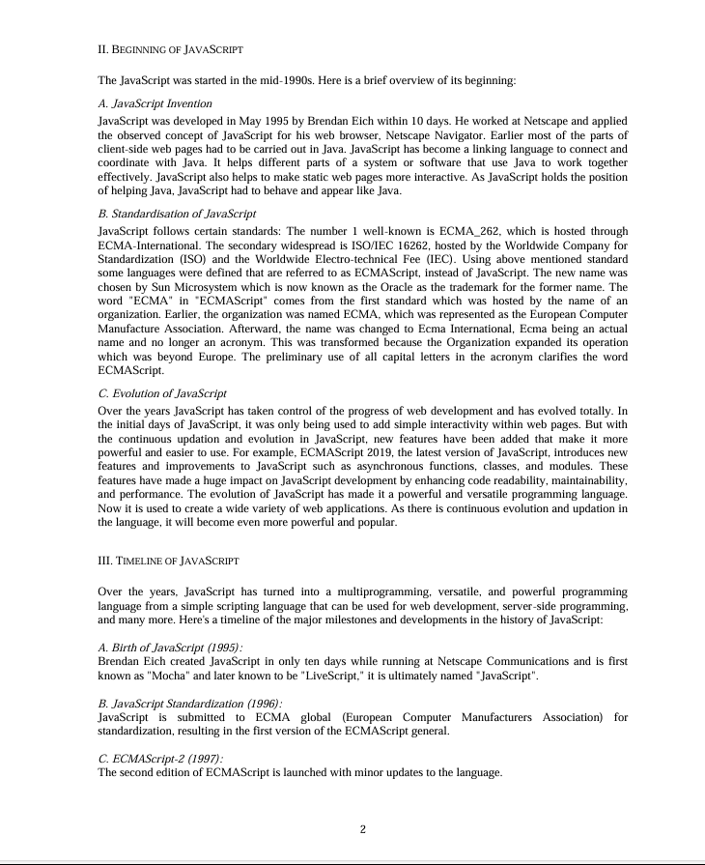

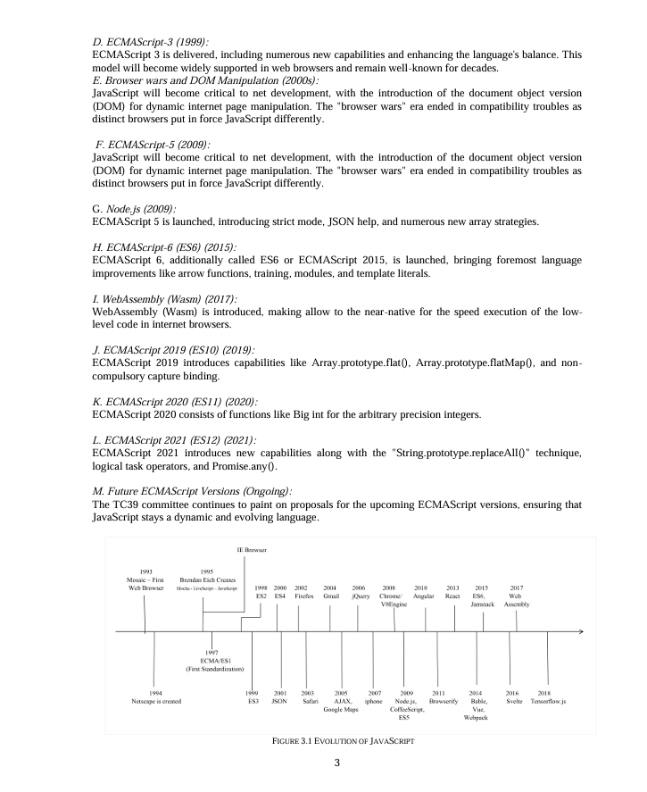

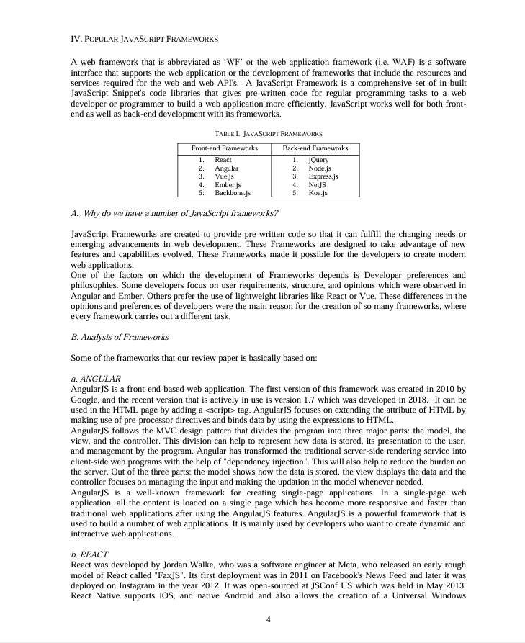

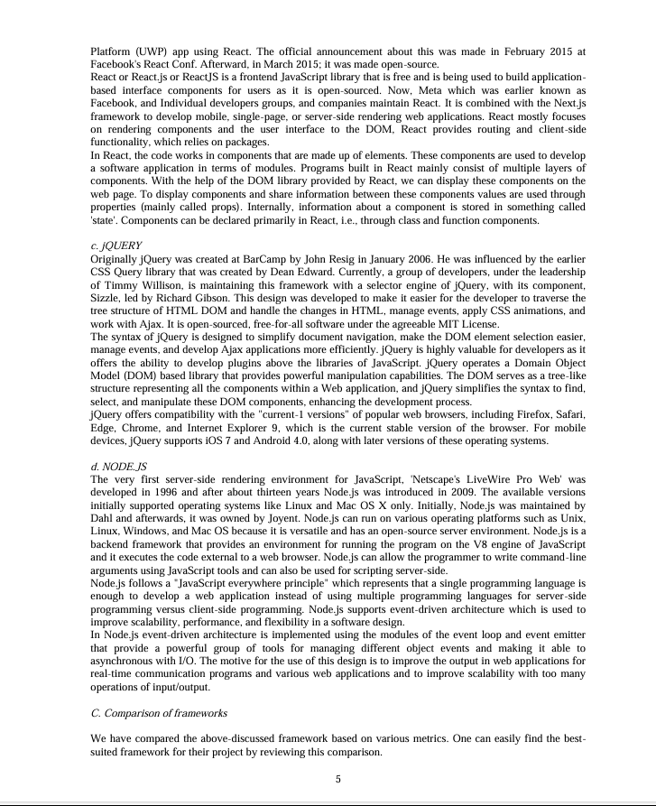

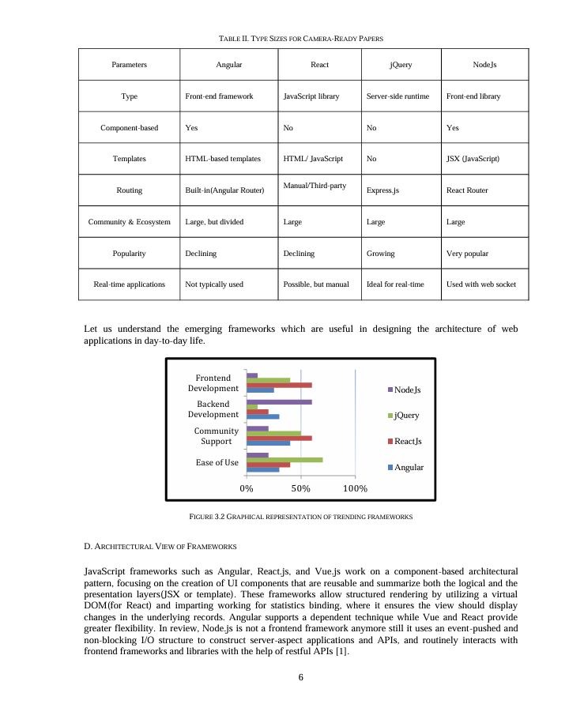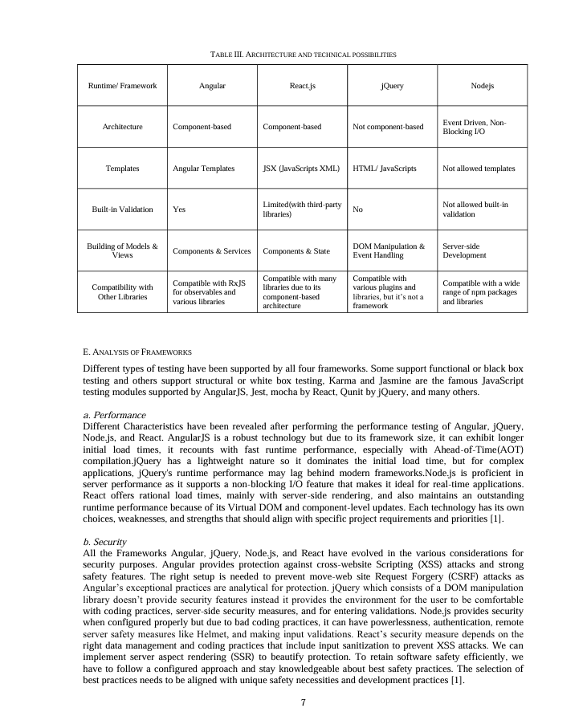

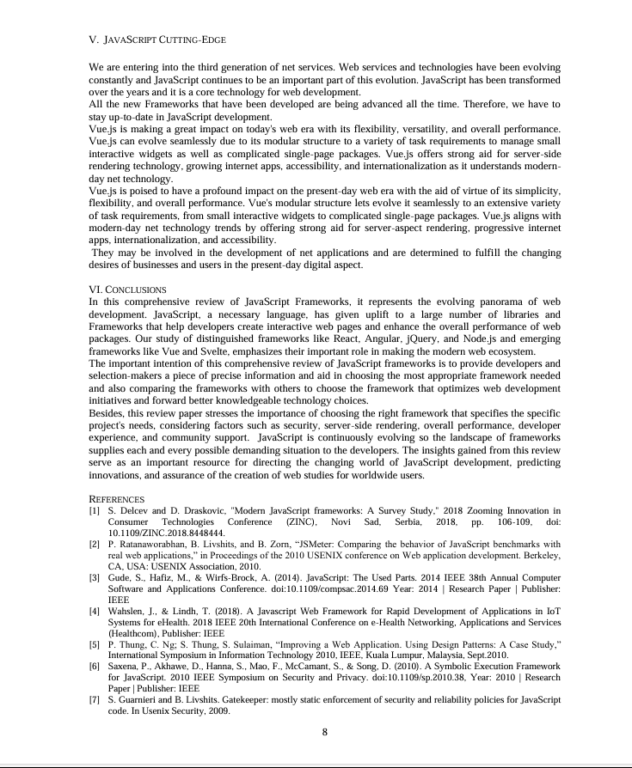

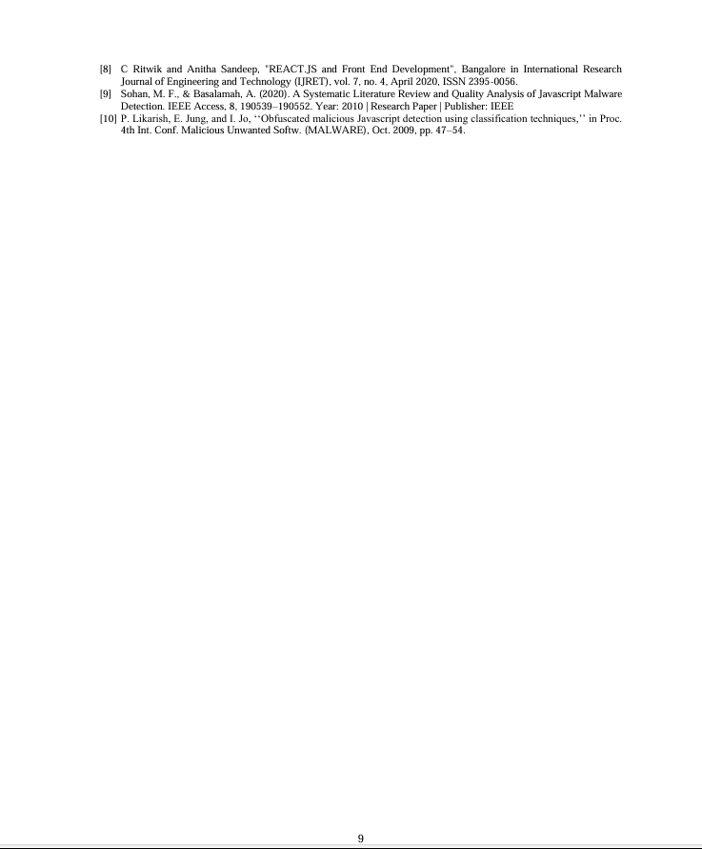

# **Certificates**

